**NN&DeepLearning_Lesson: Autoencoders**

**NAME: Bala Rishik Marneni**

**Student id: 700746746**

**Githib Link:** [**https://github.com/BalaRishik001/Neural-Networks-and-Deep-Learning-Assignments**](https://github.com/BalaRishik001/Neural-Networks-and-Deep-Learning-Assignments)

**Video Link:** [**https://drive.google.com/file/d/1GLf-ajZWoNLXxH5d2PRvoZXy8y-Ev4vo/view?usp=drive_link**](https://drive.google.com/file/d/1GLf-ajZWoNLXxH5d2PRvoZXy8y-Ev4vo/view?usp=drive_link)

Lesson Overview:

In this lesson, we are going to discuss types and applications of Autoencoder.

Programming elements:

1. Basics of Autoencoders
2. Role of Autoencoders in unsupervised learning
3. Types of Autoencoders
4. Use case: Simple autoencoder-Reconstructing the existing image, which will contain most important features of the image
5. Use case: Stacked autoencoder

In class programming:

1. Add one more hidden layer to autoencoder

|  |
| --- |
| 1. Do the prediction on the test data and then visualize one of the reconstructed version of that test data. Also, visualize the same test data before reconstruction using **Matplotlib** 2. Repeat the question 2 on the denoisening autoencoder 3. plot loss and accuracy using the history object |

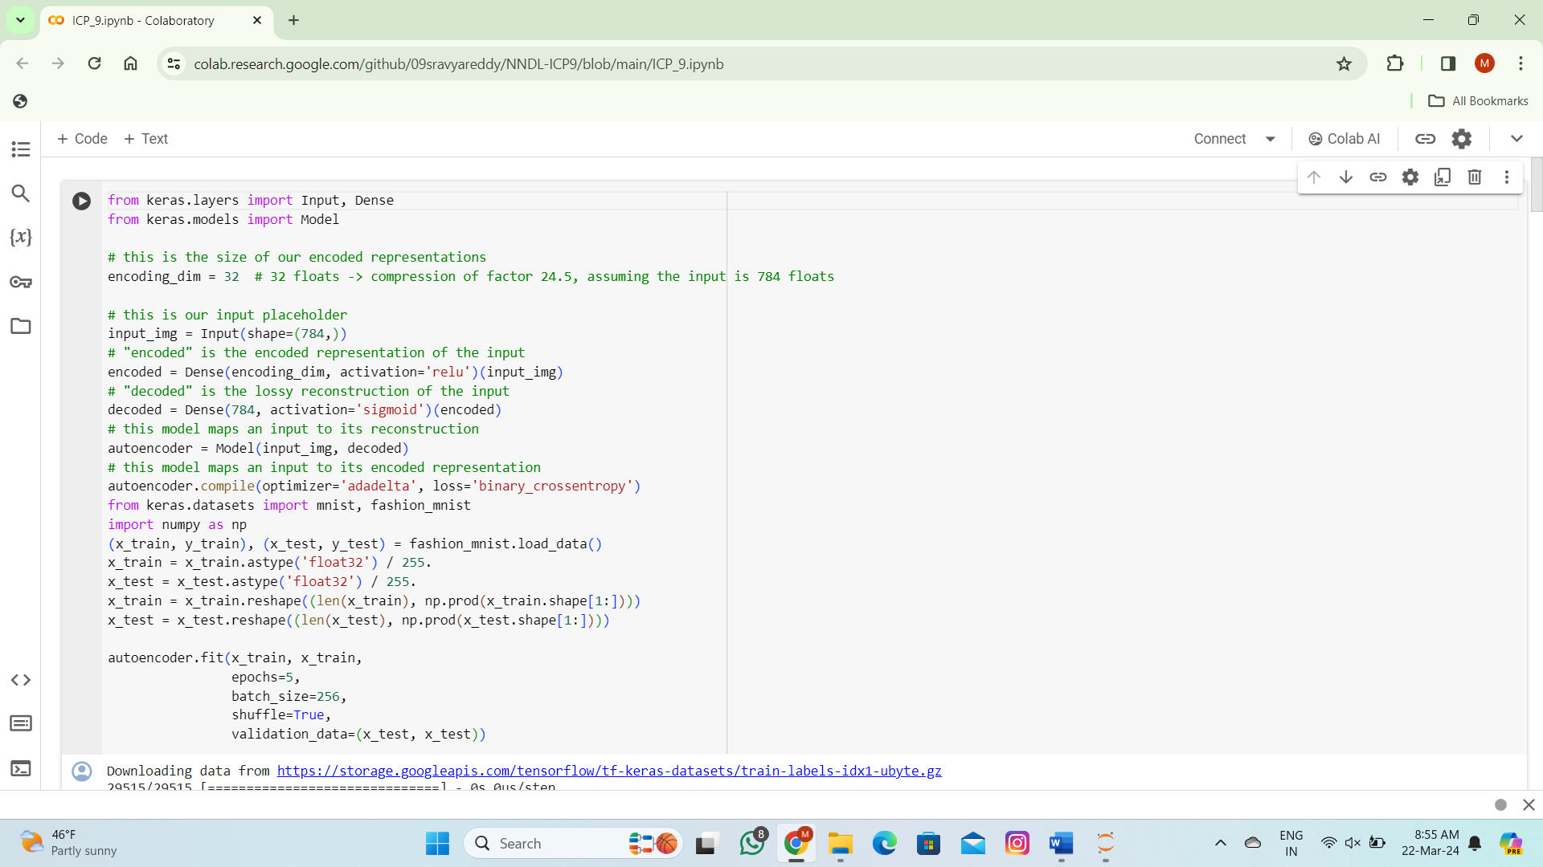

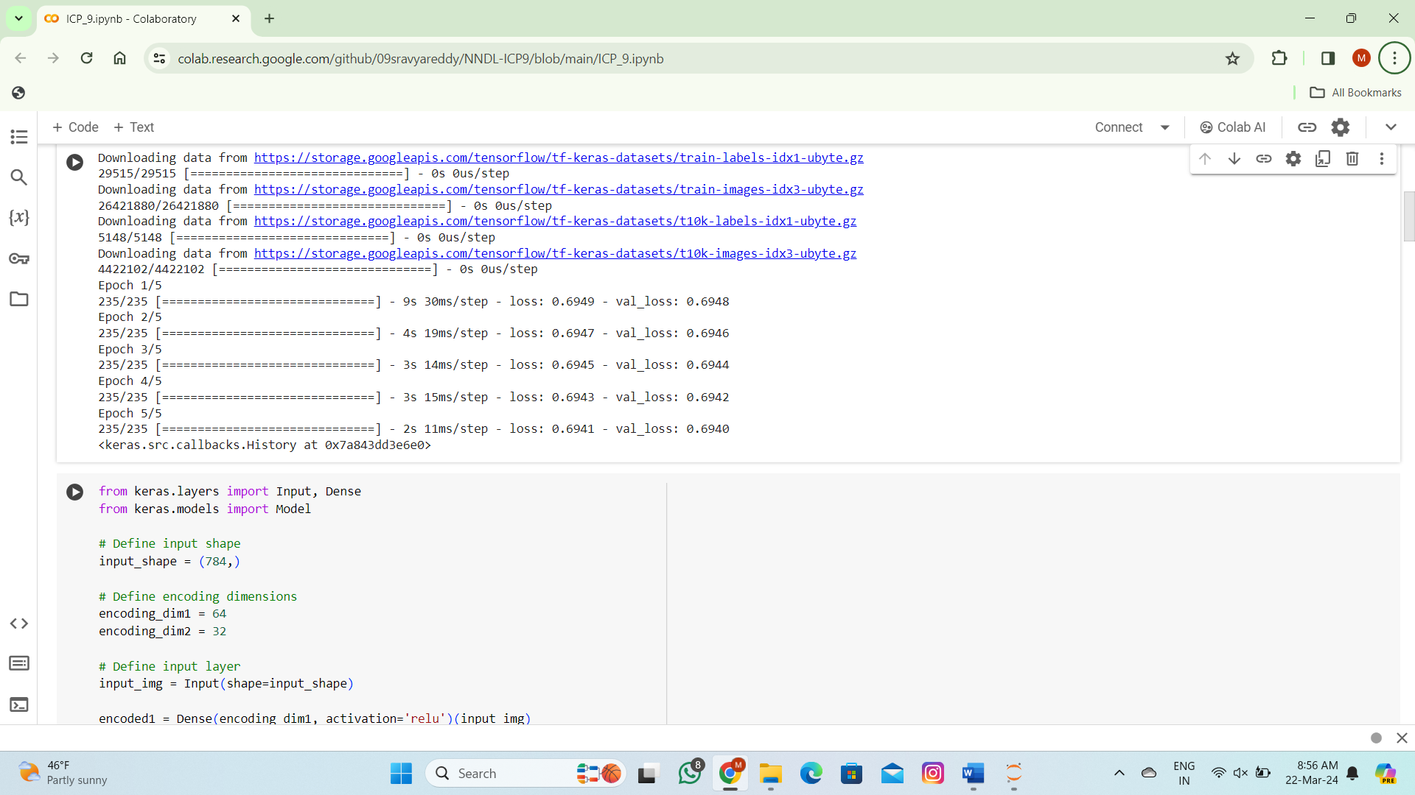

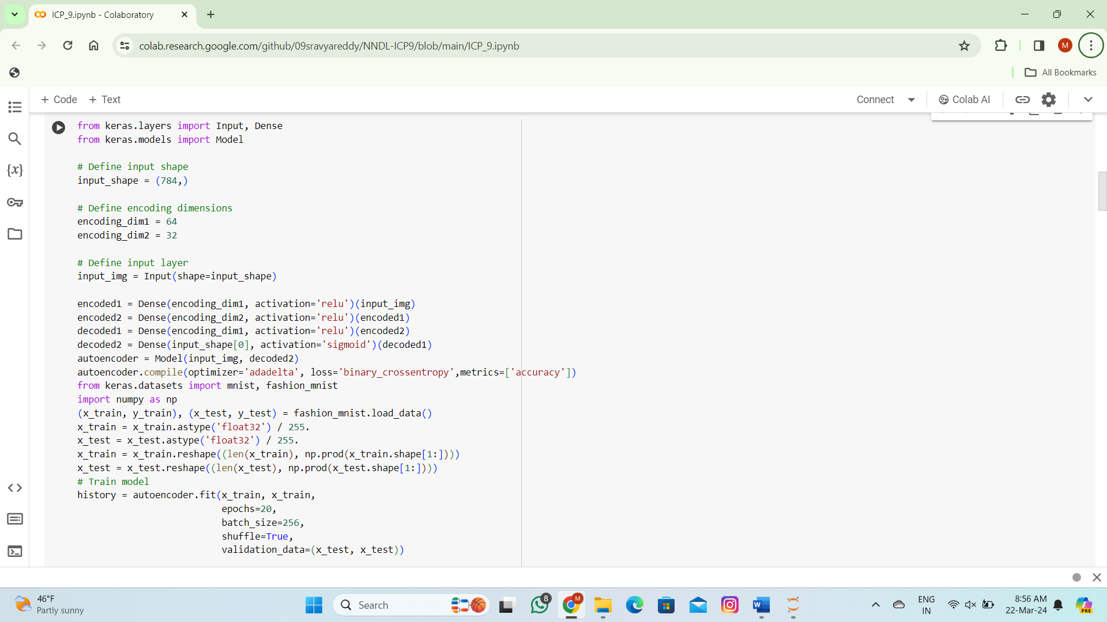

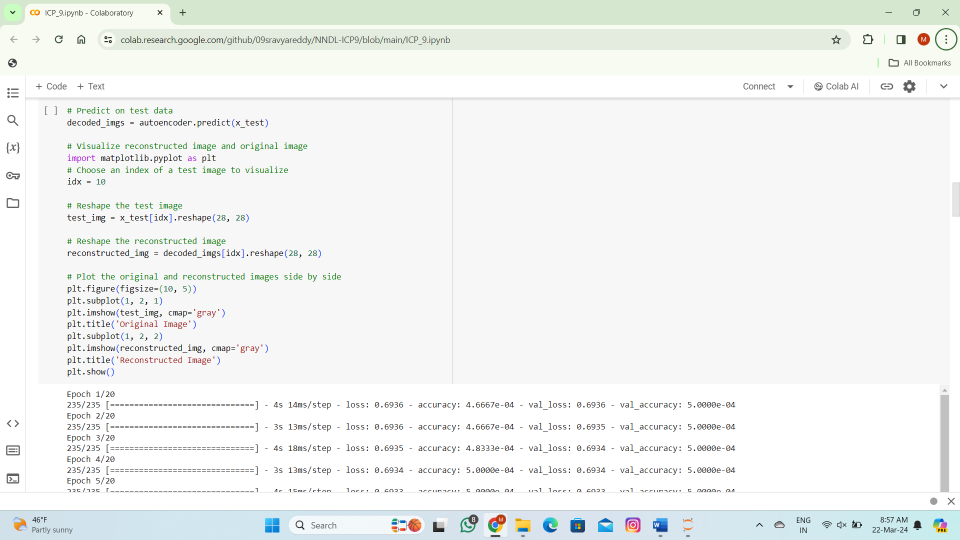

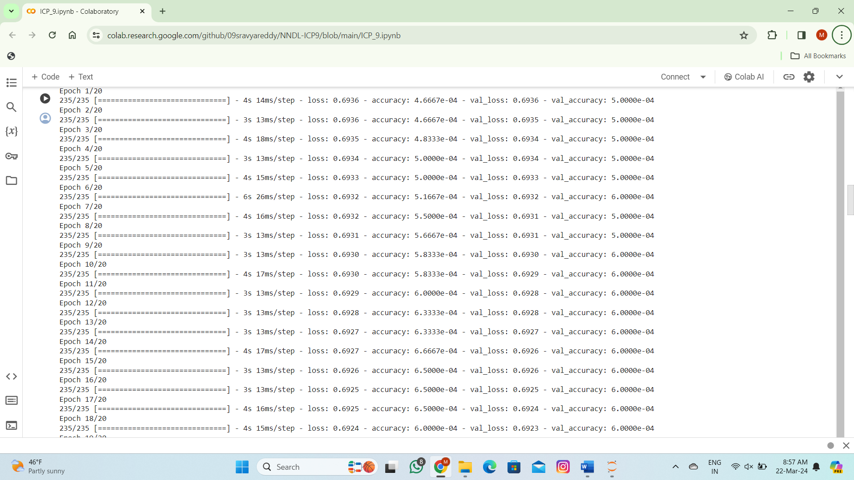

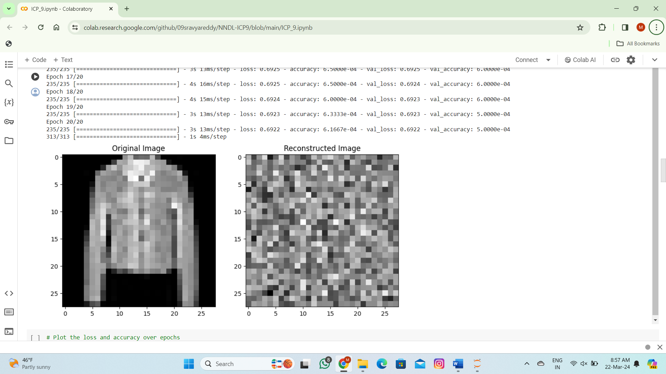

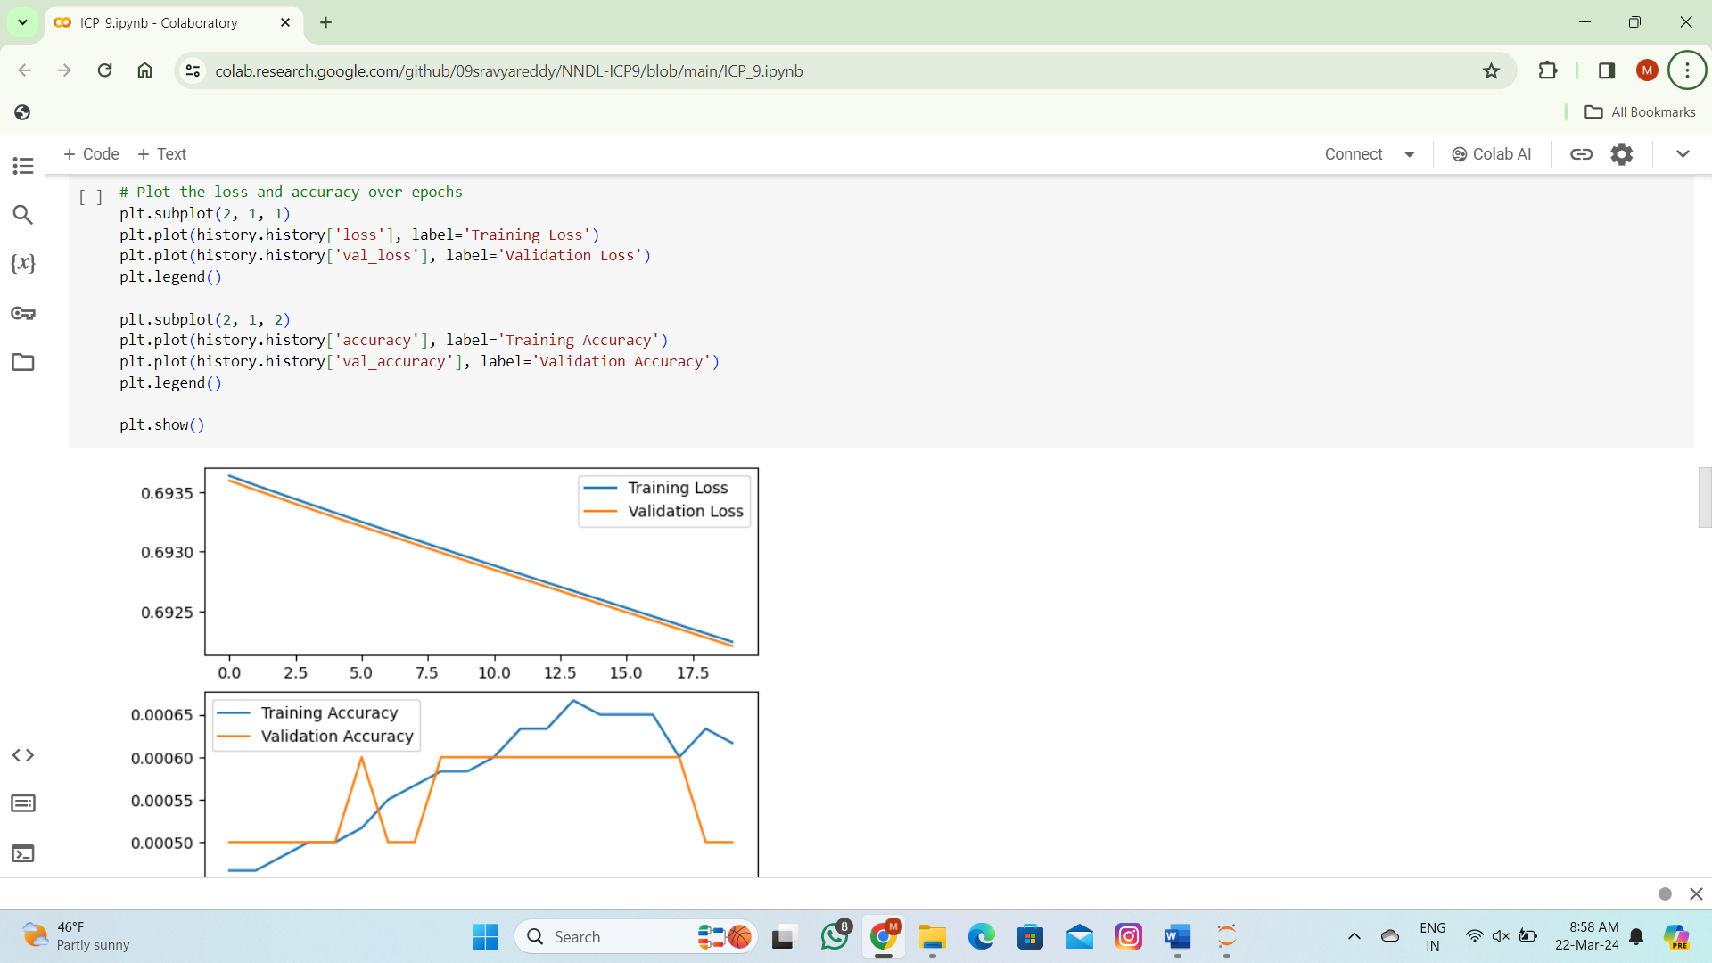

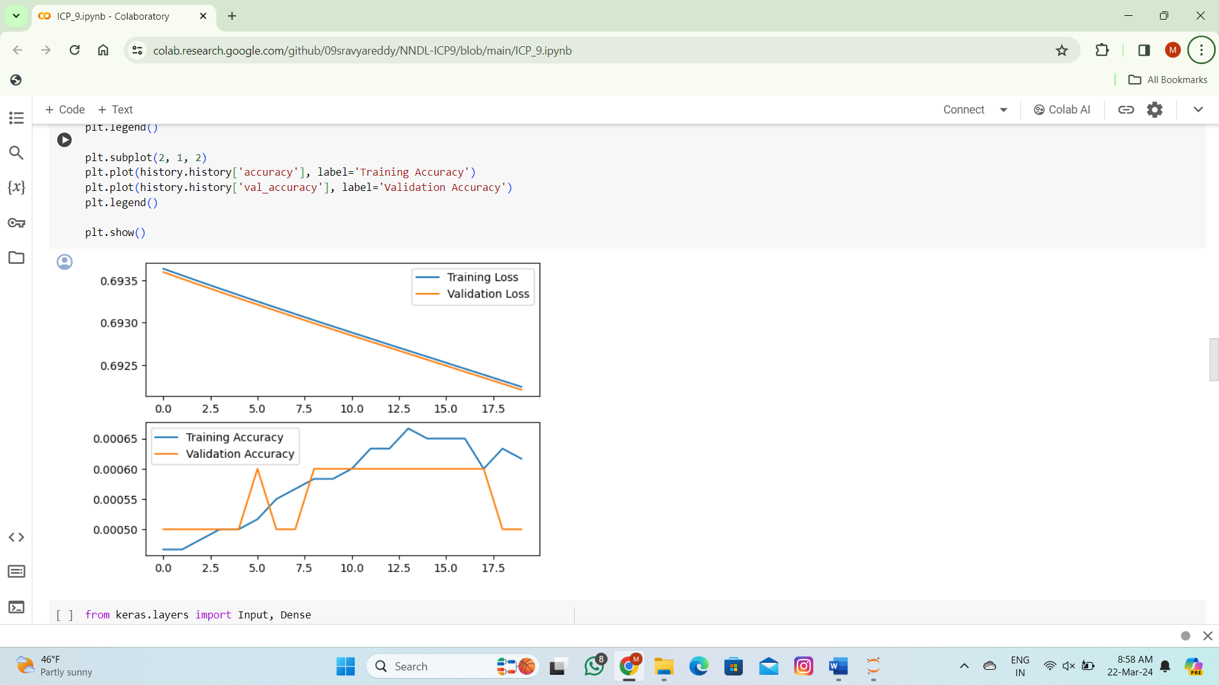

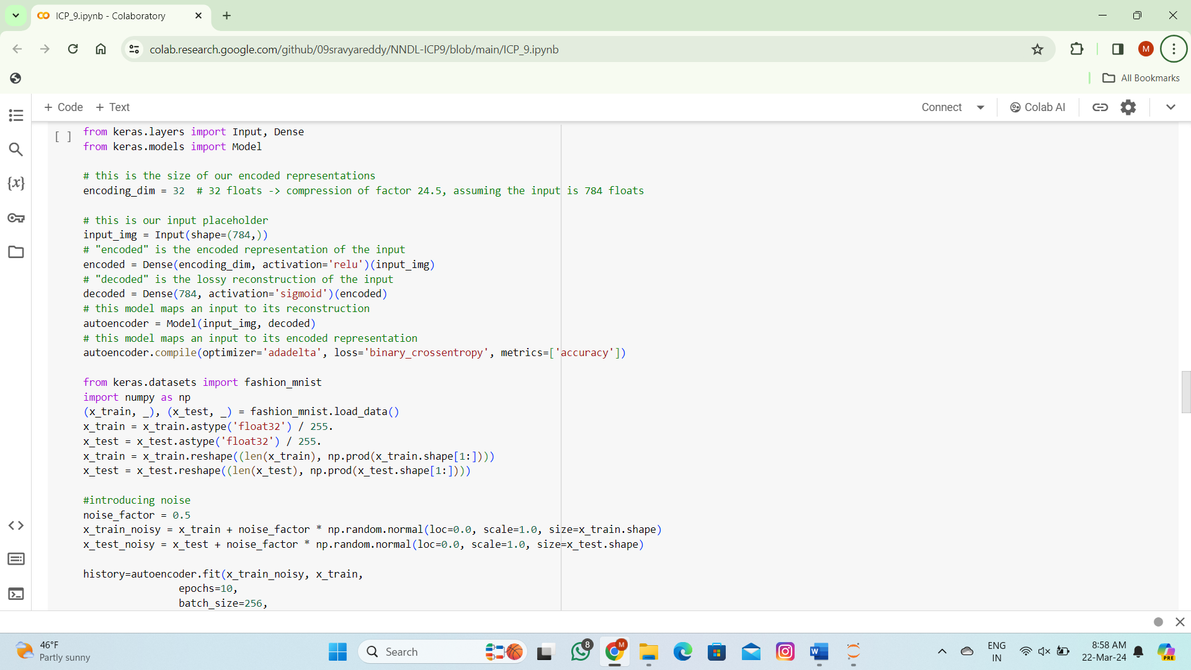

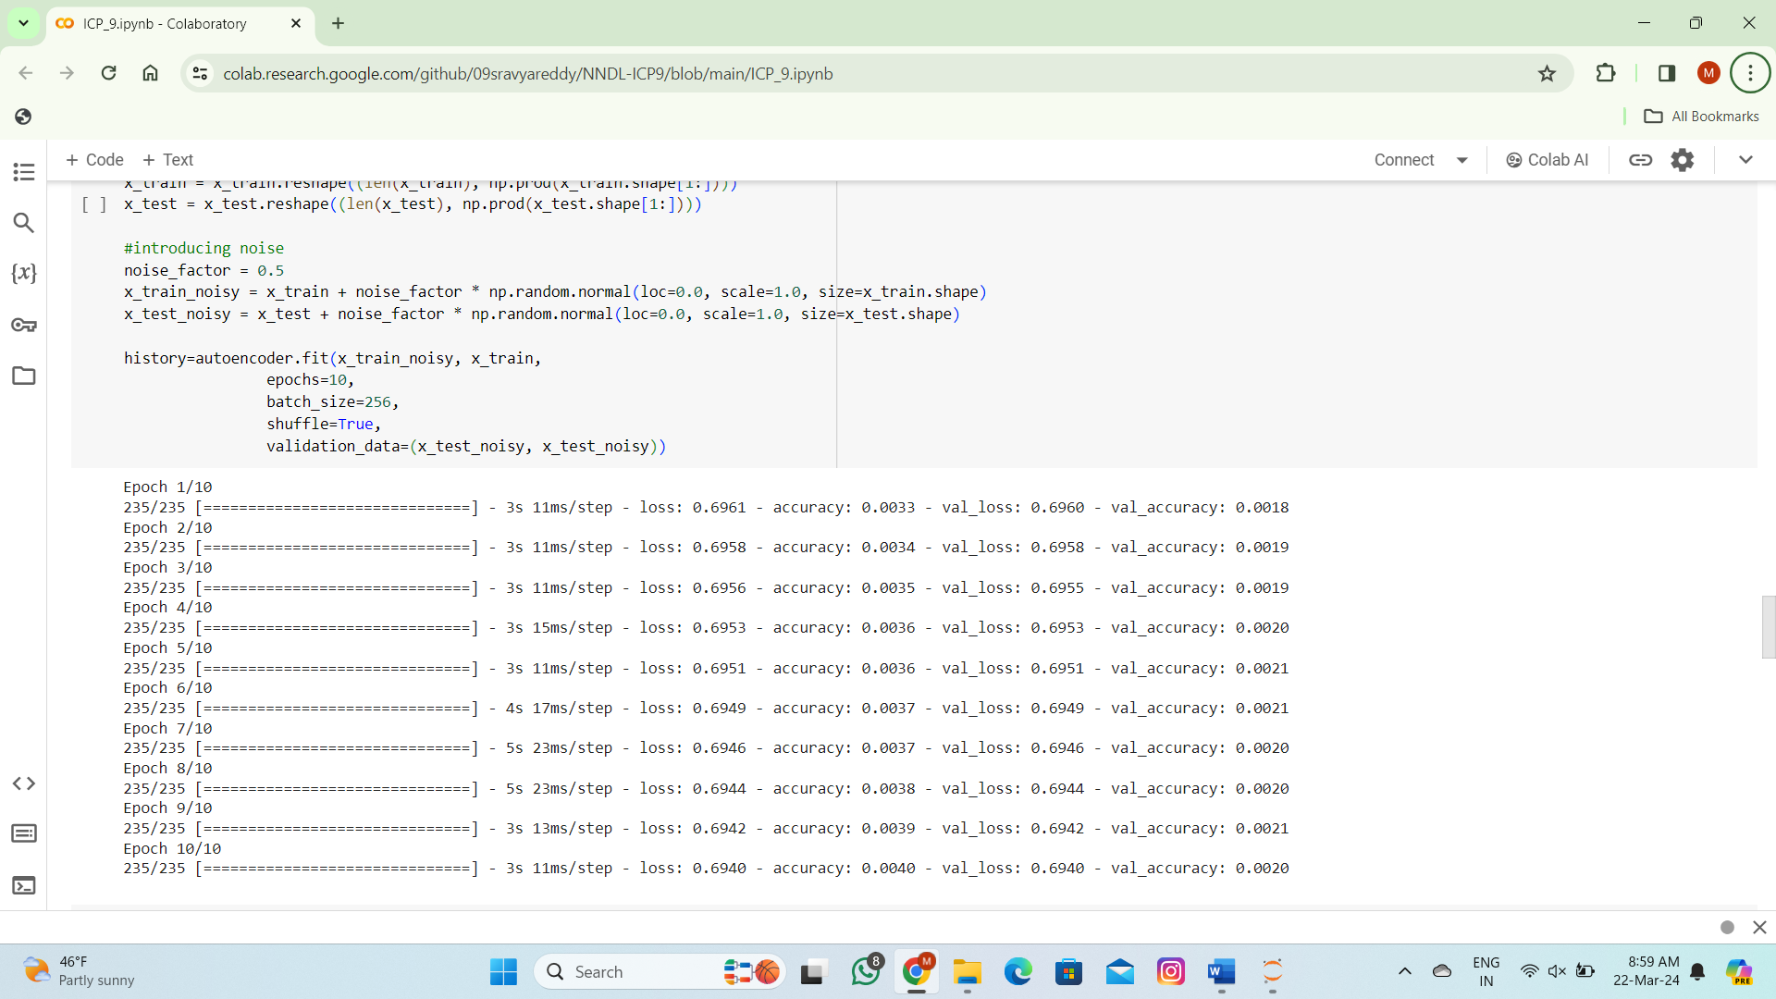

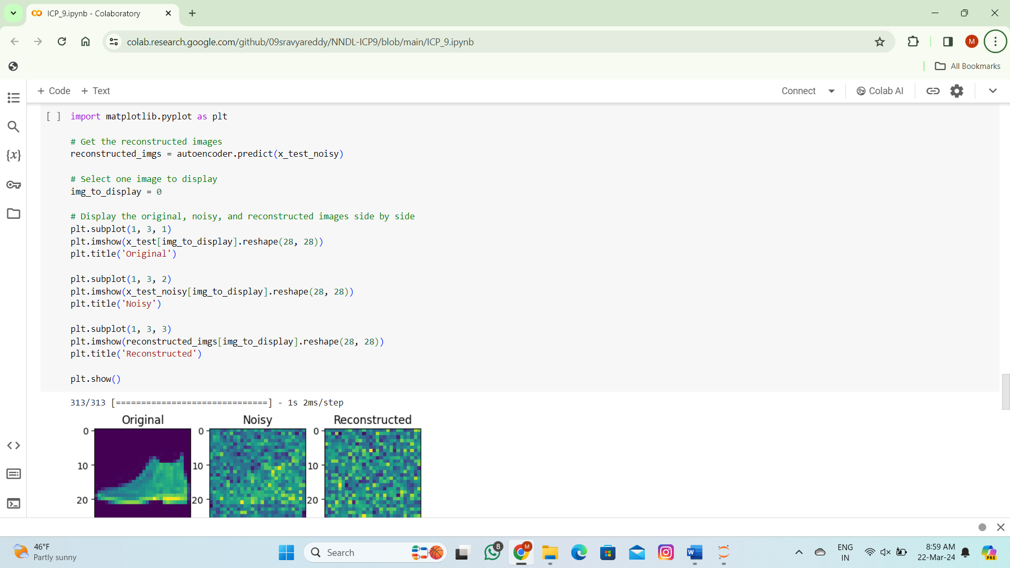

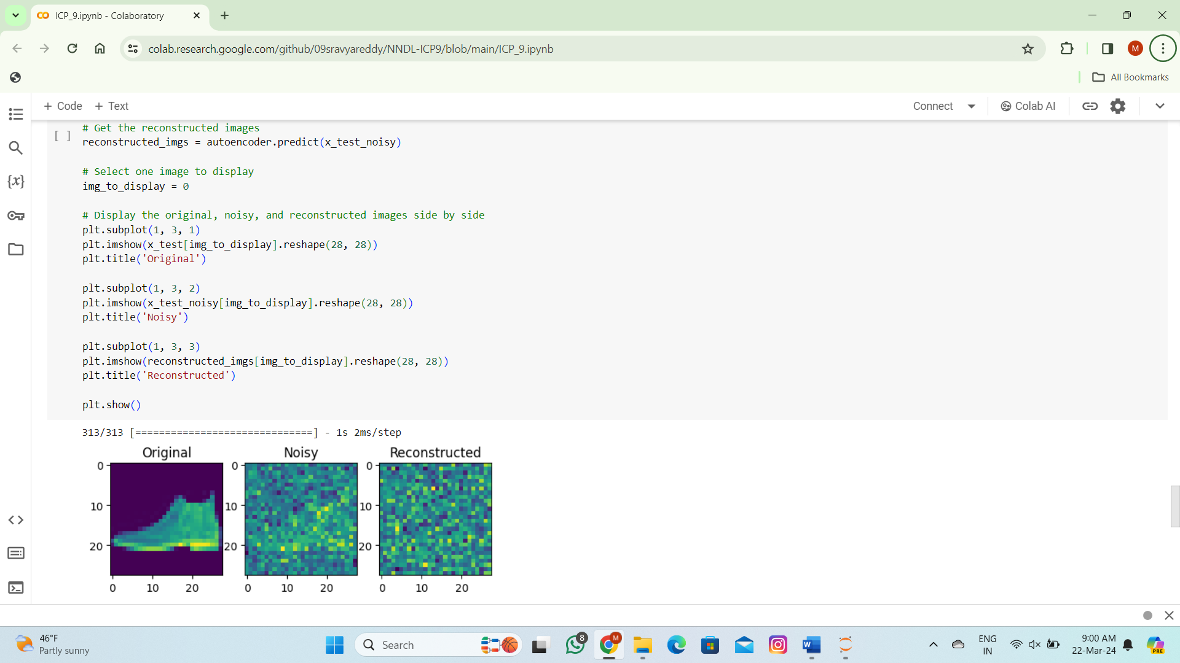

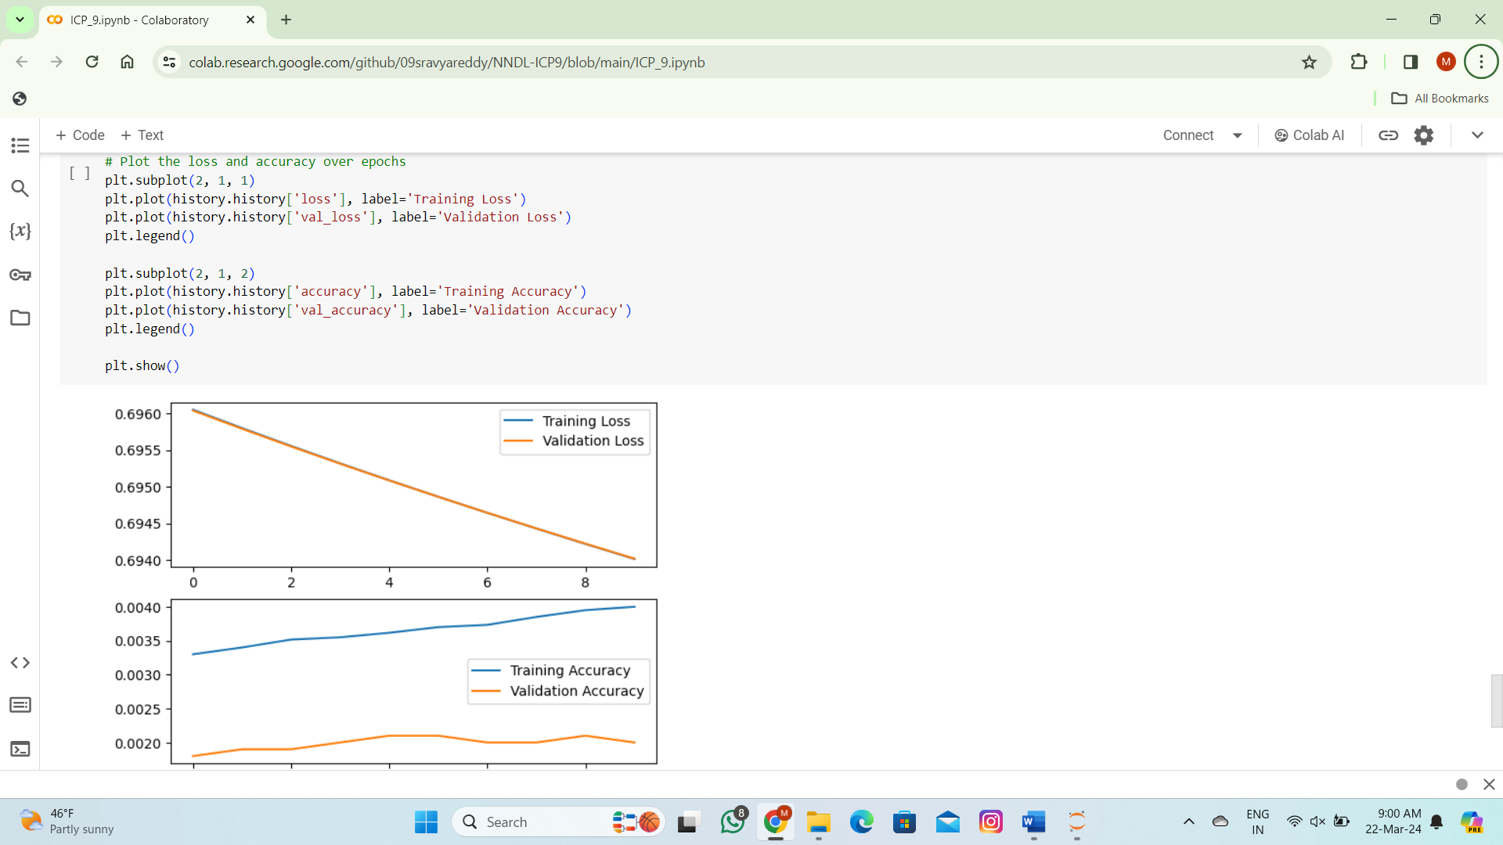

**THANK YOU**